ASSIGNMENT 3

Scanner Class

Name : Anam Bushra

Class : CS “B” II Year

Roll No. : 20C3110

1. Write a program to delete duplicate from an Array.

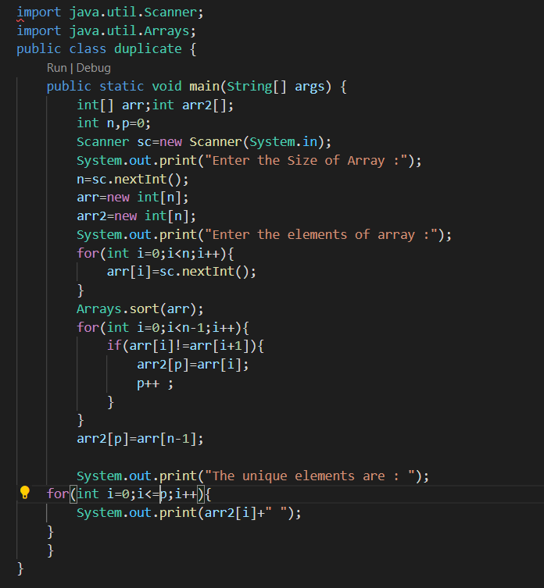

OUTPUT:

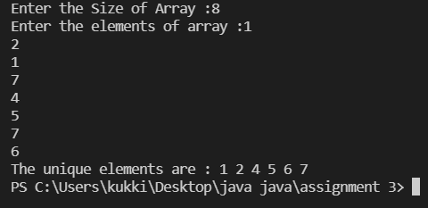

2. Write a program to calculate Area of the circular region, take radius of inner and outer circles from the user.

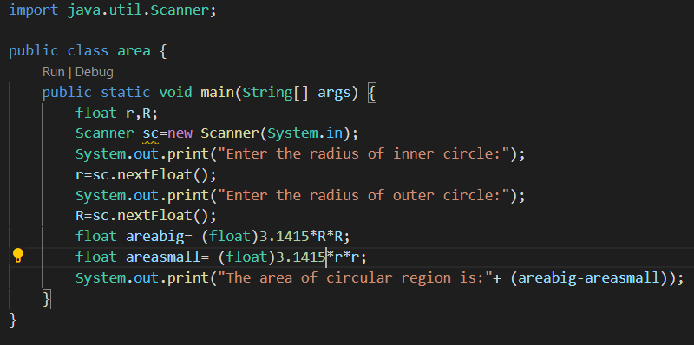

**OUTPUT:**

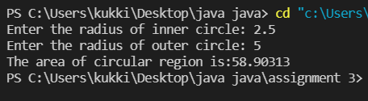

3. Write a program to find numbers of Vowels in a string.

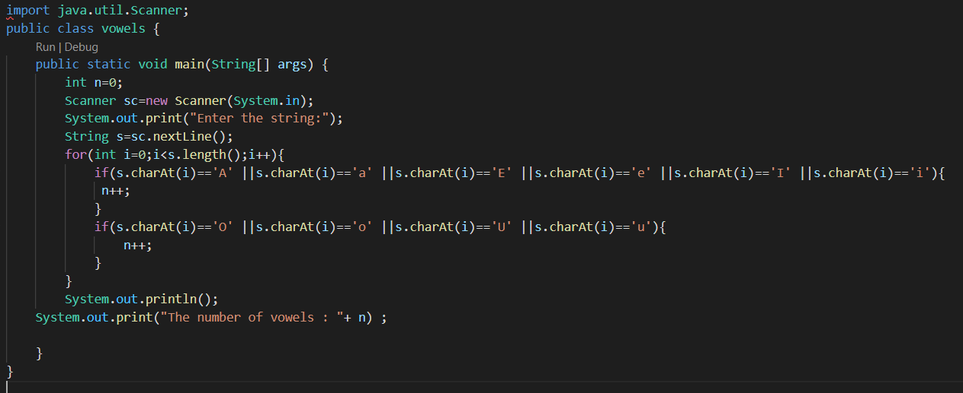

**OUTPUT:**

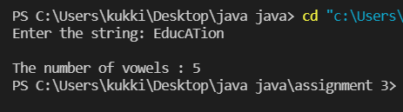

4. Write a program for addition, subtraction and multiplication of the Matrix.

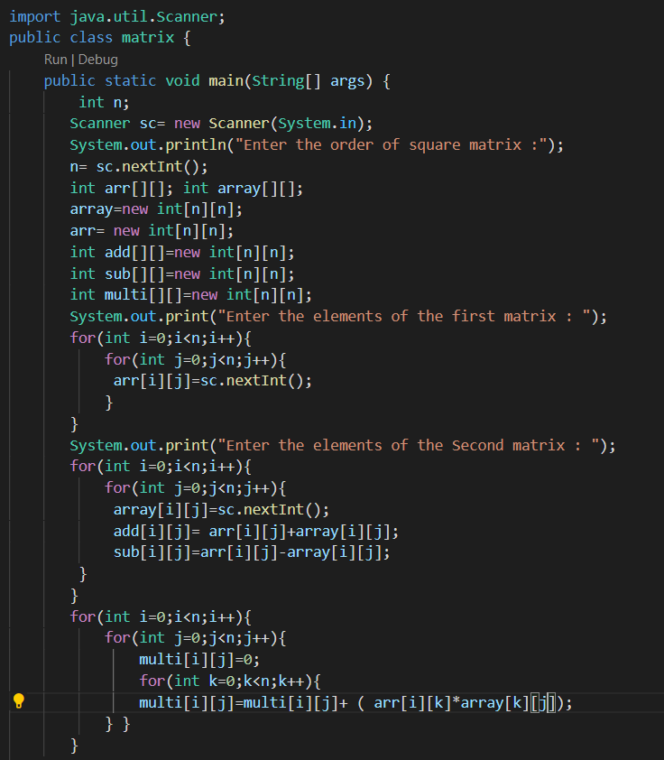

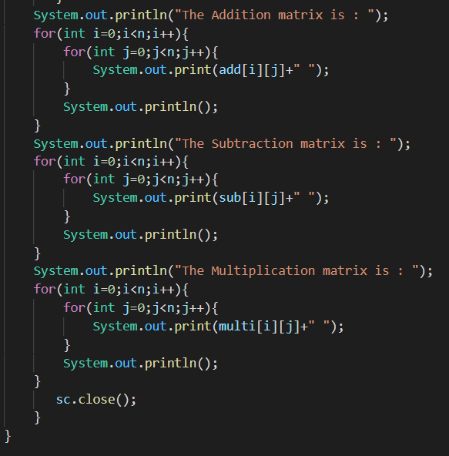

**OUTPUT:**

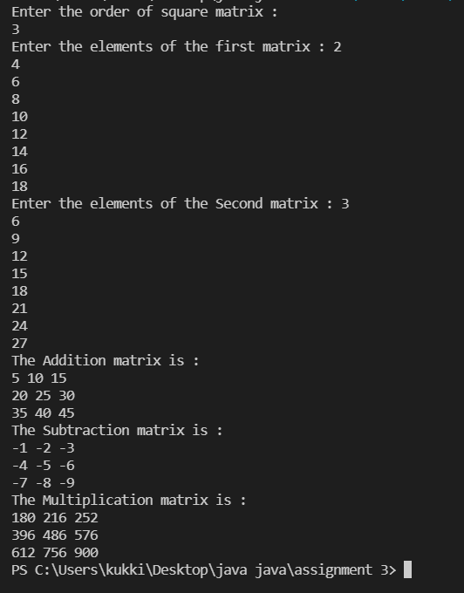

5. Write a program to calculate bubble sort, insertion sort and selection sort using switch case.

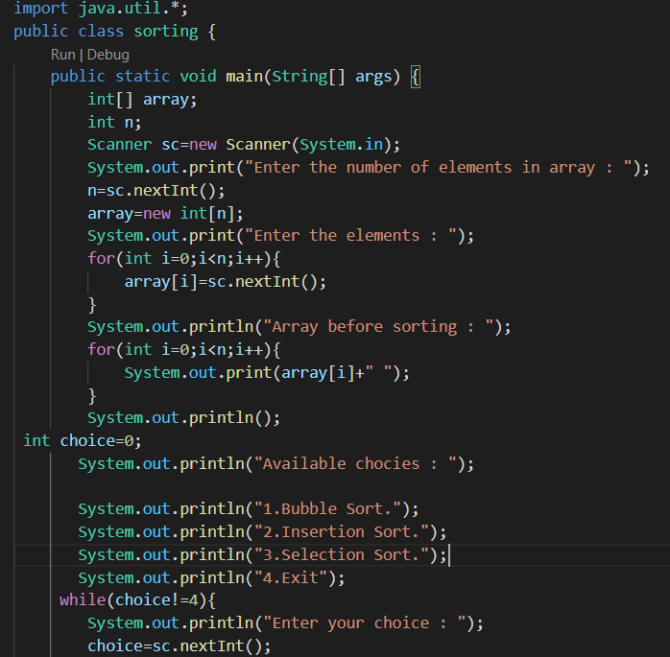

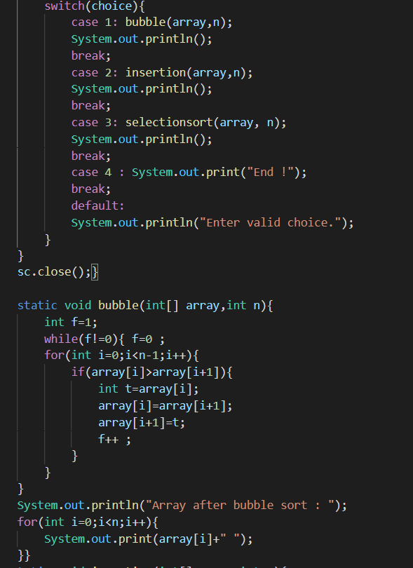

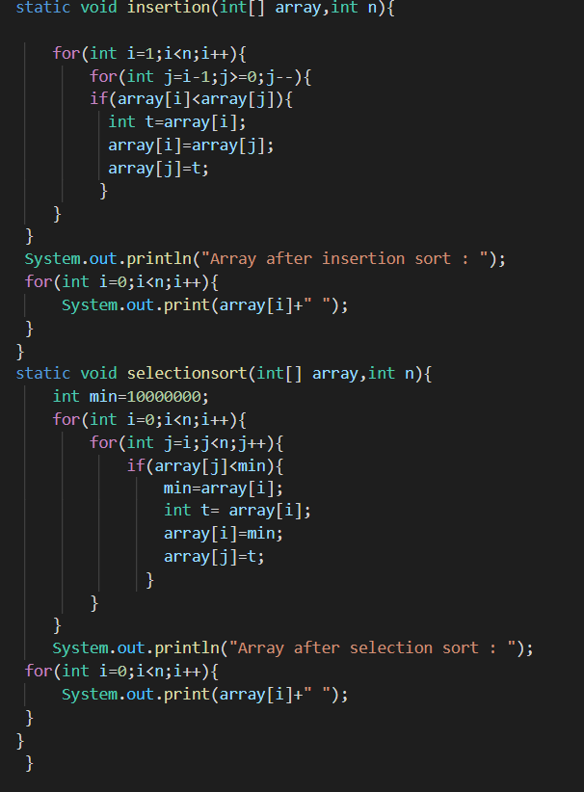

**OUTPUT:**

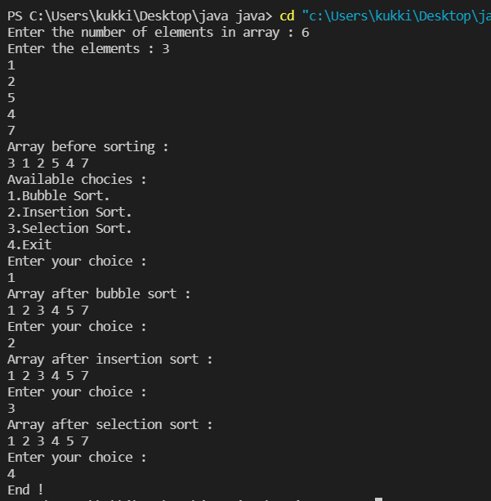

6. Write a Java program to get a number from the user and print whether it is positive or negative.

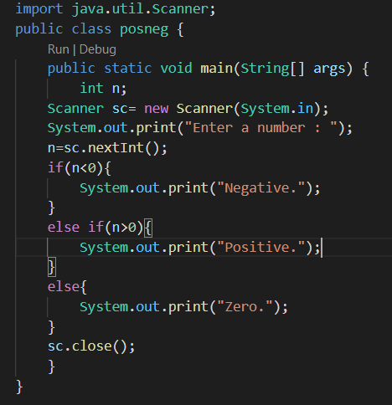

**OUTPUT :**

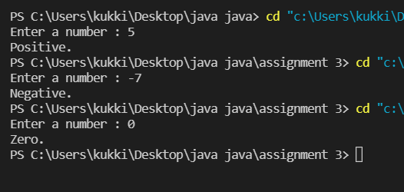

7. Write a Java program that reads a floating-point number and prints "zero" if the number is zero. Otherwise, print "positive" or "negative". Add "small" if the absolute value of the number is less than 1, or "large" if it exceeds 1,000,000.

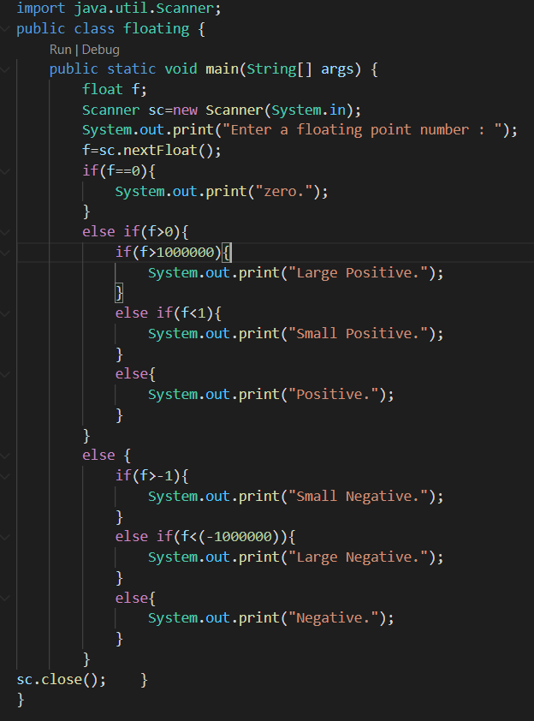

**OUTPUT:**

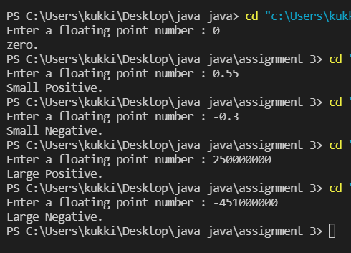

8. Write a Java program that keeps a number from the user and generates an integer between 1 and 7 and displays the name of the weekday.

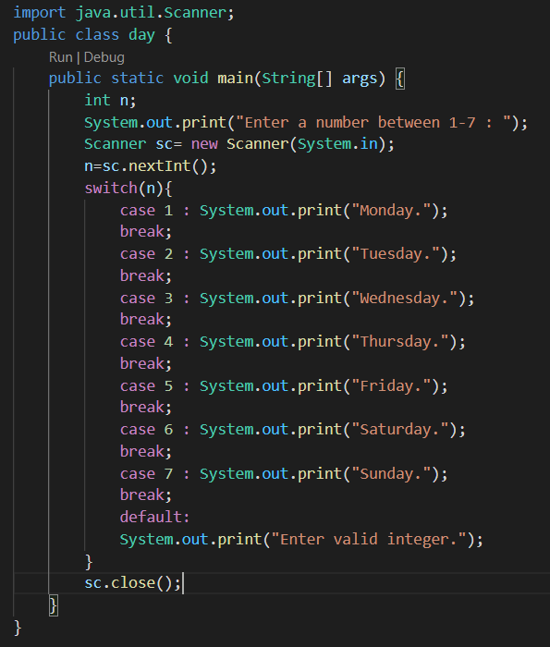

**OUTPUT:**

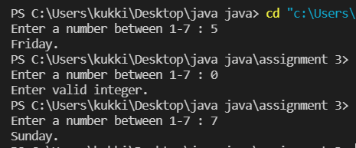

9. Write a program in Java to display the cube of the number up to given an integer.

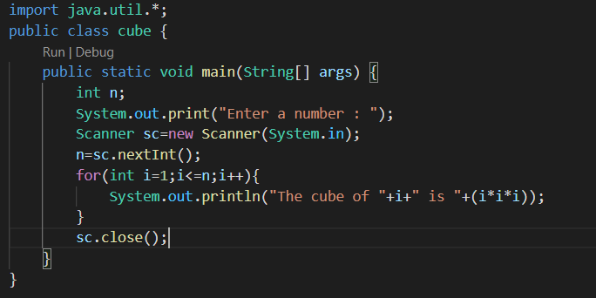

**OUTPUT:**

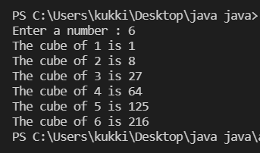

10. Write a program that accepts three numbers from the user and prints "increasing" if the numbers are in increasing order, "decreasing" if the numbers are in decreasing order, and "Neither increasing or decreasing order" otherwise.

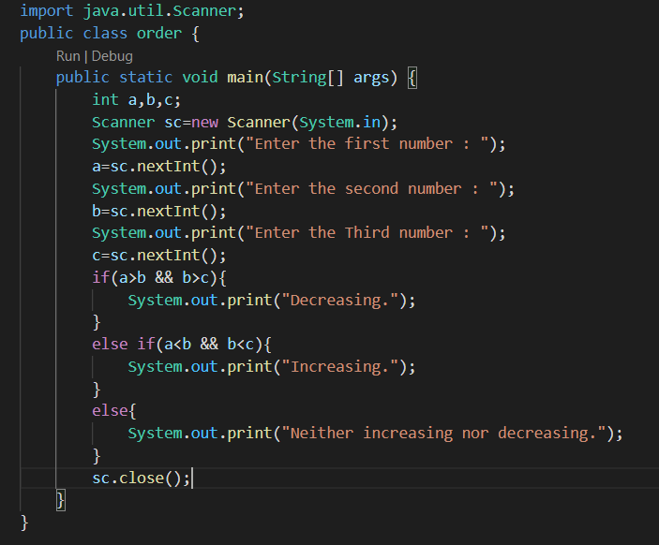

**OUTPUT:**

